Ideation Phase
Define the Problem Statements

Date | 31 October 2026
Team ID | NA
Project Name | Electric Vehicle Market Performance & Insights
Maximum Marks | 2 Marks

Customer Problem Statement Template:
Create a problem statement to understand your customer's point of view. The Customer Problem Statement template helps you focus on what matters to create experiences people will love.
A well-articulated customer problem statement allows you and your team to find the ideal solution for the challenges your customers face. Throughout the process, you’ll also be able to empathize with your customers, which helps you better understand how they perceive your product or service.

Reference: https://miro.com/templates/customer-problem-statement/
Filled problem statements:
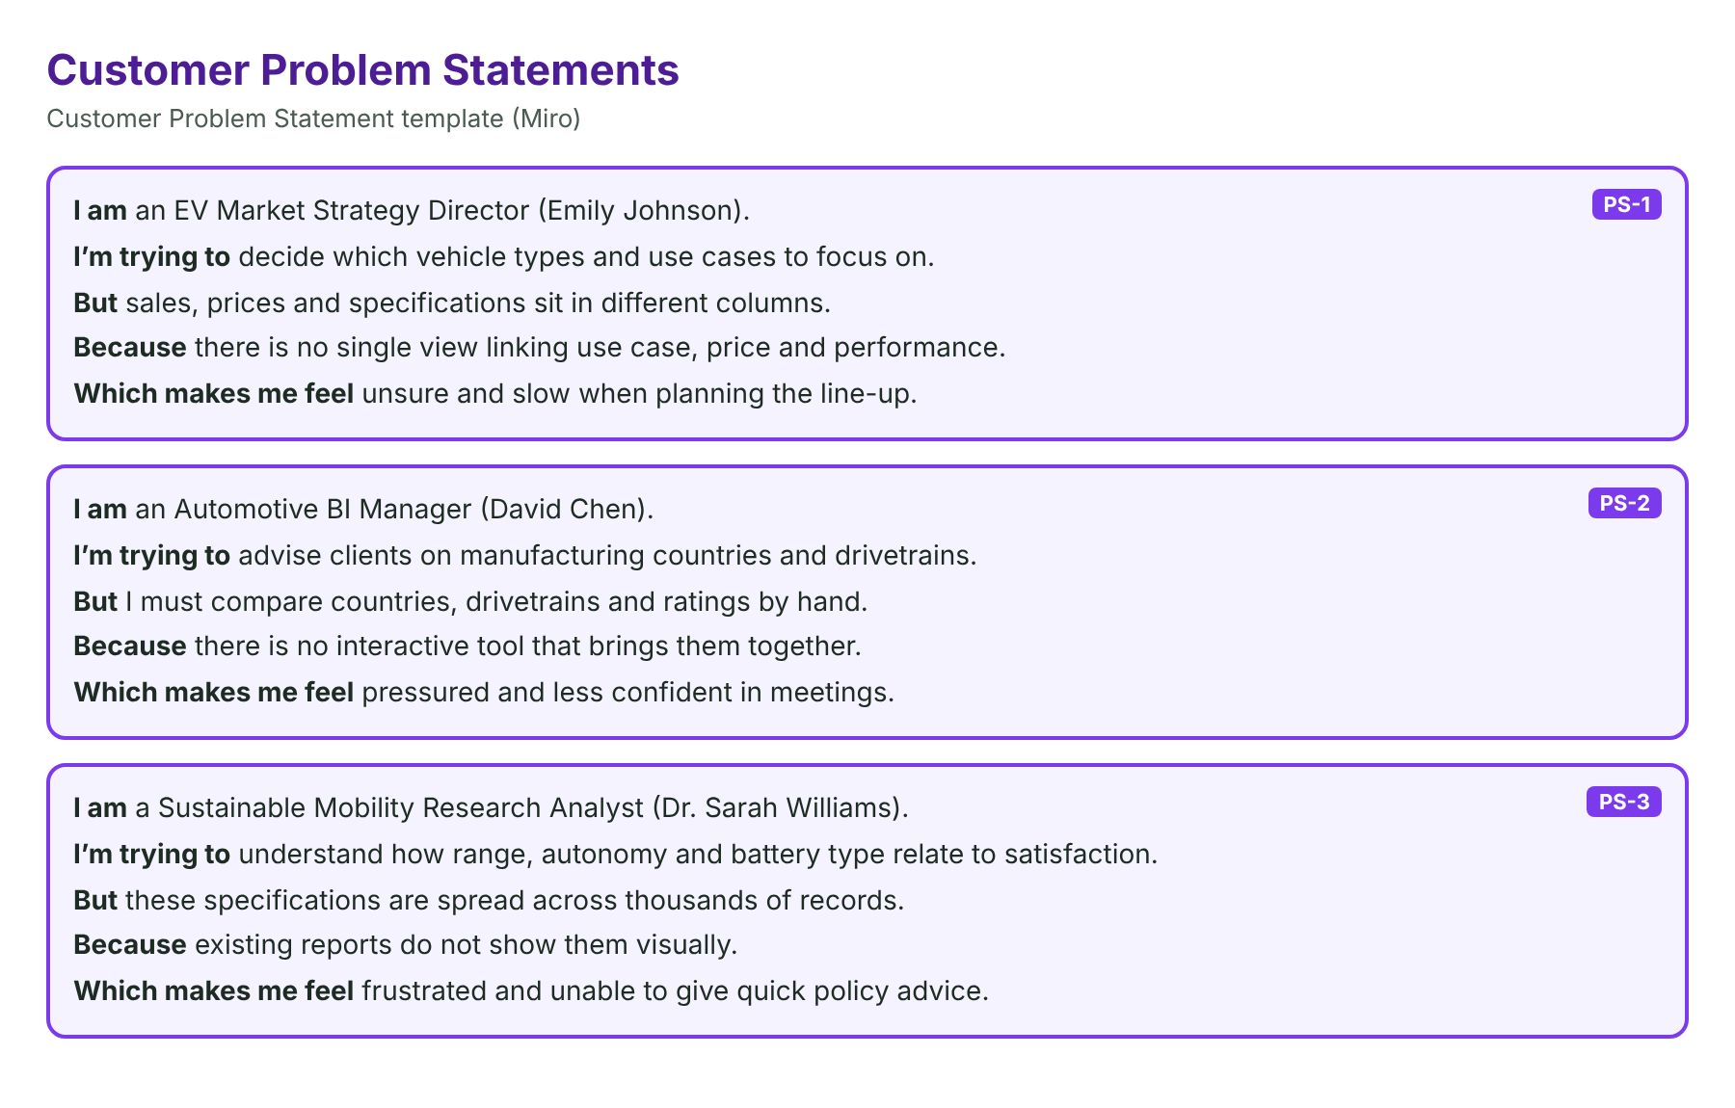
Problem Statement (PS) | I am (Customer) | I’m trying to | But | Because | Which makes me feel
PS-1 | an EV Market Strategy Director (Emily Johnson) | decide which vehicle types and use cases to focus on | sales, prices and specifications sit in different columns | there is no single view linking use case, price and performance | unsure and slow when planning the line-up
PS-2 | an Automotive BI Manager (David Chen) | advise clients on manufacturing countries and drivetrains | I must compare countries, drivetrains and ratings by hand | there is no interactive tool that brings them together | pressured and less confident in meetings
PS-3 | a Sustainable Mobility Research Analyst (Dr. Sarah Williams) | understand how range, autonomy and battery type relate to satisfaction | these specifications are spread across thousands of records | existing reports do not show them visually | frustrated and unable to give quick policy advice

